### Writing again

+ one-pass writing

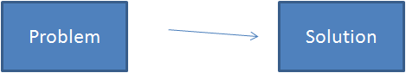

+ critical writing

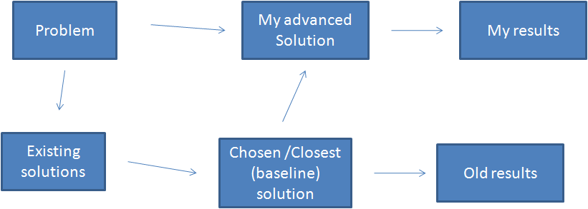

+ writing in parts

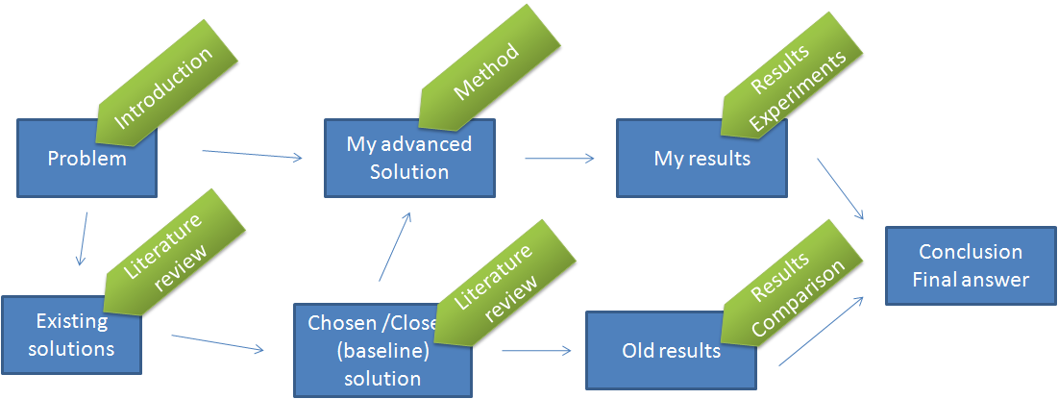

### Inventing / designing a new solution (the designed pattern)

|  |  |  |
| --- | --- | --- |
| + why existing methods fail? What are their limititions?  + if you cannot find the limitations or failure of existing methods, then why don’t you use them | + why does your method work? | + show me the proof |
| if you join 10k movies / songs with full join  >> 100 M joining operations  >> 100 K seconds to complete 1.15 days | If we use **java map** with year as **sub key**, we can reduce the number of mathes to 1/1000  >> it takes 100 sec to complete | + we implemented our method in java 1.8  and it takes generatl 2 minutes to complete 10K movies  + our key to success is to divide the large group into smaller subset without **hurting** the similarity |

### Writing in action

|  |  |  |
| --- | --- | --- |
|  | movie | song |
| introduction | + compare documents  + compare movies | + why do we need to compare songs? why do we need to recommend next songs to audience? |
| literature review | + why existing method fail or invalid or limitations? | + can we apply document comparing methods to song comparing methods?  + can we compare two authors (writers) as two documents? |
| our method | + what makes you success? |  |
| our method or applications | + youtube movie recommendation  + movie clustering | + youtube song recommendation  + song clustering |
| conclusion |  |  |